**Shreyas G N**

**241059048**

**LINUX OS & SCRIPTING LAB**

**M.E – CYBER SECURITY**

The main aim of this lab session is to provide hands-on experience on

* Getting Help
* Basic Commands
* Navigation
* File System
* simple shell script

1. Getting Help

|  |  |  |  |  |
| --- | --- | --- | --- | --- |
| Task | Command Name | Syntax | Example | Screenshots |
| To get manual page for the known command | man | man <command> | man ls |  |
| To get manual page for the unknown command | apropos | apropos <command> | apropos ls |  |
| To know the source file binary | which | which <command> | which ls |  |
| To know the path of the command | whereis | whereis <command> | whereis ls |  |
| To know the command is external or internal | type | type <command> | type ls |  |
| To get help for the internal command | help | help <command> | help cd |  |
| To list out bash commands | compgen | compgen -c | compgen -c |  |
| To know the usage of the command | <command> --help | <command> --help | ls –help |  |

1. **Basic Commands**

|  |  |  |  |  |
| --- | --- | --- | --- | --- |
| Task | Command Name | Syntax | Example | Screenshots |
| To know today’s date | date | date | date |  |
| To print calendar | cal | cal | cal |  |
| To print kernel version | uname | uname -r | uname -r |  |
| To print default shell | echo | echo $SHELL | echo $SHELL |  |
| To print currently logged in user | whoami | whoami | whoami |  |
| To create shortcut for command | alias | alias <shortcut_name> = <command> | alias hi =ncal |  |
| To delete shortcut | unalias | unalias <shortcut_name> | unalias hi |  |
| To change the timestamp of the file | touch | touch <file> | touch myfile |  |
| To clear the screen | clear | clear | clear |  |
| To create empty files | touch | touch<file> | touch myfile |  |
| To know disk usage | du | du -h | du -h |  |
| To know free space in the system | df | df -h | df -h |  |
| To know about the Linux release | lsb_release | lsb_release | lsb_release |  |

1. **Navigation**

|  |  |  |  |
| --- | --- | --- | --- |
| Task | Command | Syntax | Screenshots |
| To navigate home directory | cd | cd |  |
| To navigate to the parent directory | cd .. | cd .. |  |
| To navigate to the child directory | cd <directory_name> | cd file |  |
| Alternate command to cd | pushd<directory> | pushd file |  |
| To go back to the previous directory | cd - | cd - |  |
| To go to the root directory | cd / | cd / |  |

1. **File System**

|  |  |  |
| --- | --- | --- |
| **Task** | **Syntax** | **Command** |
| **How to identify the file system** | **df -T** | **df -T** |

1. Create Folder “CYS”
2. Navigate to CYS
3. Create folder LS1 and LS2 under CYS
4. Go back to CYS
5. Working with Files
6. Add commands which you learnt during lab session in the file commands.txt
7. Change the timestamp of the file to yesterday
8. Copy the contents from the file commands.txt to commands_demo.txt
9. Rename the file commands_demo.txt to duplicate
10. Rename all .html to .hldd
11. Delete the file duplicate
12. Copy the contents commands.txt to unit4 and unit5 (using relative path)
13. Delete the contents from unit5 (using absolute path)
14. Navigate to root
15. List all the files under root
16. Explore all the folders (Do not delete any folder)
17. Navigate to /etc/passwd
18. Open the file passwd
19. Explore the file passwd
20. Navigate to /etc/group and explore
21. **Difference between**
22. **GUI vs. CLI**:
    * **GUI (Graphical User Interface)**: Interfaces that allow users to interact with electronic devices using graphical icons and visual indicators.
    * **CLI (Command Line Interface)**: Interfaces that allow users to interact with the computer by typing commands into a terminal or console.
23. **man vs. info**:
    * **man**: Provides a manual page for commands with a focus on concise, specific information.
    * **info**: Provides more detailed and structured documentation, often including explanations, examples, and links to related topics.
24. **which vs. whereis**:
    * **which**: Shows the path to the executable of a command.
    * **whereis**: Locates the binary, source, and manual pages for a command.
25. **Terminal vs. Shell**:
    * **Terminal**: A terminal emulator that runs a shell and allows users to input commands.
    * **Shell**: The command-line interpreter that processes commands and returns the output.

**Simple Shell Script**

* **Task**: Write a simple shell script to print your name and your hobbies.
  + **Example Script**:

**Interesting Commands to Explore**

1. **Banner**:
   * **Command Name**: banner
   * **Description**: Prints text as a large banner.
   * **Example**: banner Hello

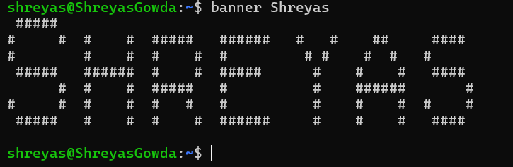

1. **History**:
   * **Command Name**: history
   * **Description**: Displays the history of commands entered in the terminal.
   * **Example**: historyTop of Form

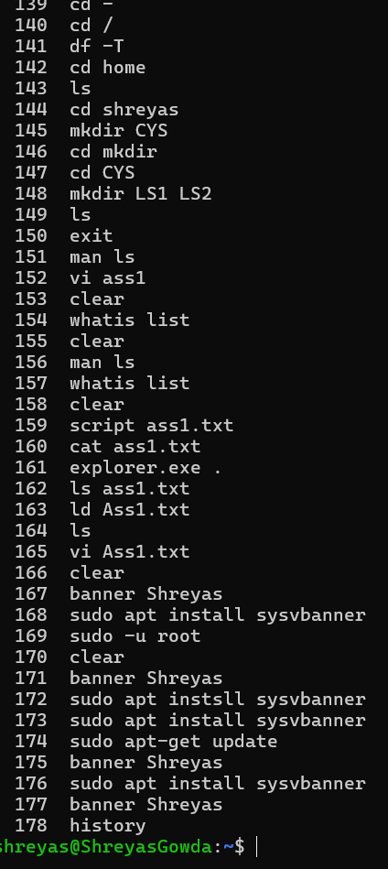

Bottom of Form

1. Write a simple shell script to print your name and your hobbies!

